 Narrative Campaign

A rising shadow

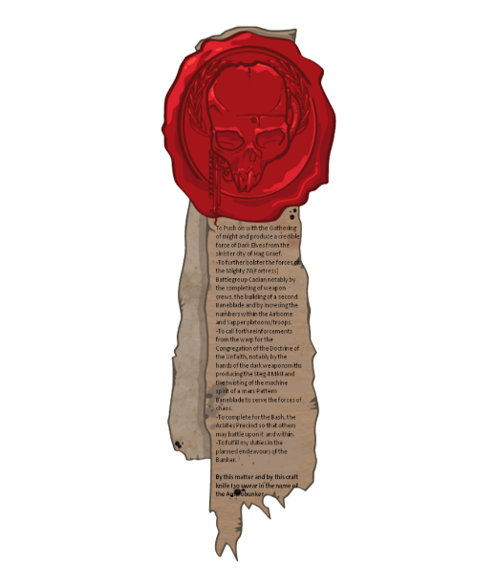



Incoming Transmission …. Xoq05qs604………..Inquisitorial Code 457

* Requesting ACCESS …. – Access denied: code level too low

Inquisitorial override CODE level VERMILION …… ACCES GRANTED

<-PLAYING MESSAGE->

This is High-Marshal Gravasz Alez

At the request of **inquisitor** **Jeracan Pytat-Brex** I have sent this message with **EXTREME** urgency. The inquisitor was here on a mission to investigate a growing unrest on the other side of **FUNANDIA TAGDIA VII** he was working to uncover a hidden cult presumed heretics and disappeared with his entourage 4 days ago. The local **Magos** of the **Adeptus Mechanicus Cassos Hextumomere** shortly after detected growing amount of bio forms at the inquisitors last known location. My army is stationed here to resupply to fight of parts of the splintered hive fleet. With the inquisitors disappearance I fear things are worse then we thought and the hive fleet has penetrated deeper into imperial space then we first suspected.

Our Astropaths are starting to stare into a shadow this message is our request for salvation and has the utmost urgency but there seems to be something ominous looming over us. Some of our regiments stationed at the other side of the world went vox silent the past days. Then suddenly one of them returned vox messages stating the situation was normal. I hope my career hasn’t been ravaged by some Num chuck buffoon from the administratum pencil pusher because this suspicious situation can be figured out by even the lowest of guardsmen.

Never the less I hear u asking “Why even send a message if u know what is going on?” I did not gain the title of high marshal by loitering / Stupidity or nepotism I earned it trough hardships and talent. Before inquisitor Jeracan Pytat-Brex went to investigate he the Magos Cassos Hextumomere and i had a meeting off the record about suspicions about some of the regiments whom faced the hive fleet in last battles, some of these guardsman seemed to act suspicious lately. The magos has started on a auspex modification made specificly for detection of infection of Bio forms this work is of the utmost importance for the future of the imperium!!! Our astropaths informed me of an impeding darkness, we do not have much time and it is hard to differentiate whom to trust in these uncertain times.

To you Whom Readest this message we need assistance and urgent.

The local Sororitas chapter under command of sister superior **Aspynvia Aspara** has been informed but I fear despite the size of our army we might not last the swarm knows we are working on something important and time seems to be running out.

I Hope this message finds the needed attention and astartes chapters available for   
 a mission of VERMILION level threat because the shadow casted over us seems to be growing and it is not just a splinter fleet coming this way but a new fleet. We lost contact with the scouting vesels.

I serve the God Emperor even in death but I would like to prolong my working period a while longer and not let this planet become a feeding ground for a new Nids fleet

…For the GOD EMPEROR of Mankind…

<-End Transmission->

The Campaign Rules 

About this campaign: This is a longer campaign about planetary conquest.  
The idea is conquest/defence depending on the perspective of the players faction.   
The grounds where it will take place have been ordered in hex grid of which a few are impassable/unusable because who would want to fight/survive in an area full of magma.

The Imperium faction will start with a certain amount of holdings more then the other players. This mustn’t dishearten players of other factions as they will have an easier way dealing with the maybe overstretched imperial forces and who knows what’s lurking in the dark?

There is a total of 108 grids of which 20 are deemed impassible/unusable these are tiles full of magma or water. Players will earn conquest points by winning battles against opposing players.

A slaughter: 20pts or more over enemy -> 3 conquest points

A victory between 10-20 pts more then the enemy -> 2 conquest points

A Pyrrhic Victory but a victory nonetheless -> 1 conquest points

These Conquest points can be spend to take over parts of the map. Or push the enemy back out of a tile. This requires 2 conquest points. The Xenos forces and chaos forces thus must first gather points for certain points of interest like cities. Outskirt towns don’t start under the control of the imperium only the named towns however the imperial player has the option to defend them but with a reduced force because of being overextended (for example: a outskirt town gets attacked the players from the imperium can defend it with 75% of the pts of their crusade force, fred not the ever “loyal” beloved PDF is at your side).

Players part of the Xenos and Chaos faction start their campaign at the outskirt of the map.  
They start with control over 1 non town hex touching the outside of the map.

To start and determine who fights who the use of a randomiser is recommended.  
The only set battles are the cities where if a player wishes to conquer it they require to fight the imperial player. Once a town has been conquered depending on which factions conquers it a different reward is given.

For The Tyrannids or Genestealer cult a town is useful biomass/genepool and they are allowed to take an extra unit to battles because of a new spawning pool(they can go over their force limit).

For the Tau once a town is conquered they will integrate the remaining population.   
They can recruit a imperial guard unit to fight alongside them which doesn’t take up points in their army.  
Or they can choose to educate the monkey and add a unit from the Tau roster which doesn’t take up pts in their army.

For the imperium successfully defending the town is not only YOUR DUTY u feth it is also a place less for u to worry about Tyrannids gaining extra forces. However successfully defending gives u the choice between 2 options:

1 Gain a blessing from a saint: Roll 2D6  
on a 2 you have been blessed by Saint Sabbat: select a character it gains Sabat Martyr increase it’s wounds by 1 and whenever this model’s wounds would be reduced to 0 roll 2d6 on a 2-4 it regains all it’s hit points but must be put in range of as many enemies as possible. For thou shall suffer a Martyr’s death.  
2 Recruit a highly trained PDF unit actually able to shoot something (this can be chosen from the Astra militarum list, with the exception of big tanks like shadowspear and other forms of it and no rogal dorn can be

taken other then these the entire roster is free to select from within reason) it does not count towards your unit limit.

For Chaos factions towns can be used as sacrifices to the dark gods for boons: Roll 1d6   
**Epic Heroes characters cannot receive blessings**

On a 2 Slaanesh offers u the power of seduction (select one character in your army it gains the following ability: Temptresses seduction when this model damages an enemy unit that unit must immediately make a battle shock test with -1 to it’s roll if this fails u may use that unit to shoot at one of your opponents units regardless if the target is in combat, if the target of this attack is in combat subtract 1 from the hit roll)  
on a 3 Khorne will bless u with slaughter (revel in slaughter one of your champions has been chosen BLOOD FOR THE BLOOD GOD add Khorne’s blessing to it’s crusade chart one of it weapons gains the lance keyword and **ADD 1** to it’s **A** however this unit now instilled with bloodlust beyond it’s normal capacities must always charge towards the closest enemy and loses -1 BS on ranged weapons for who would use such cowardly weapons you GAK)  
on a 4 Nurgle will awnser your prayer (select one unit from your army’s crusade list it gains Nurgle’s blessing: add 1 Toughness, but everything comes at a cost, they lose 2” M)  
On a 5 Vashtor will extend some of his knowledge (choose a unit add Vashtor’s blessing to it’s crusade chart select one of it’s ranged weapons it gains -1 AP and +1A however your weapons machine spirit has become warp infested and you must always target the furthest enemy models in your visible range with the weapon)

# Map Info & Hazards

* The rolls to check for hazards are made after a mission is chosen and before armies are deployed.
* Towns
  + Populated areas with minor PDF presence
    - A guard force of 500 pts joins the imperial defenders however not as brave as normal guardsmen
    - The PDF army has -1 to leadership and -1 to BS and WS after all they aren’t as well trained as a real guardsmen!
* Named Towns
  + Highly populated areas with medium PDF presence
    - A guard force of 750 pts joins the imperial defenders however not as brave as normal guardsmen
    - The PDF army has -1 to leadership and -1 to BS and WS after all they aren’t as well trained as a real guardsmen!
* Hives
  + High density of population with Major PDF presence
    - A guard force of 1000 pts joins the imperial defenders however not as brave as normal guardsmen
    - The PDF army has -1 to leadership and -1 to BS and WS after all they aren’t as well trained as a real guardsmen!
  + A hive is more then one Hex and will take longer to conquer so multiple battles will be required to conquer these well defended positions
* PDF forces rules
  + This army is predetermined check lists bellow of what they contain (if u do not have these models proxies can do as long as these are distinguishable from each other and your armies)
* Terrain:
  + Barren part
    - Such barren lands leave little to no imagination nor water lying around, the Adeptus Mechanicus have used these areas as a dumping site. Highly toxic and draining barrens best steered away from but also a way to get to the cities.
    - Charge rolls fail if double a number **(double sixes etc.)**
    - Due to high toxicity and the burning sun damage can’t be reduced**(rules saying reduce dmg by X)** however feel no pains still work
  + Forest

* + - 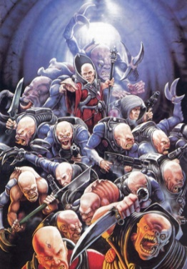These woods so little space between the trees. Sounds coming from every side, what might they mean? Are there just many hidden animals out there? Remain vigilant at night. To conquer these tiles players must move at a slow pace 2 conquest points are required to conquer a forest.
  + City
    - Cities are an interesting spot for combat! Any fine strategic mind can employ tricks to ruin their enemies plan by making use of the surrounding buildings. As a wise warlord once said: Bomb an abandoned city to the ground so u get rid of the vermin as well as your enemy
    - In City combat certain armies may have difficulties in a number of ways:
      * Always check the sewers!!! **(if a tyrranid/Genestealer cult player is part of this campaign before combat on a city tile roll 2D6 on a 10+ spawn genestealer cult models, ADD 1 to this roll if it is a small city , if it is a named city add 2, if it is a hive city add 3)**
        + If a Xenos faction is participating in this battle they count as reinforcement for this player and they decide where to deploy them after all armies are deployed
        + If no faction has the Xenos keyword spawn these models within 4”behind the defenders spawn outside of the map, these forces take their turn before any of the players and will shoot and charge. Treat them as a mob mentality npc, they will attack closest units whom they can kill (for example a group of neophytes won’t try to kill a titan but instead opt for the vulnerable infantry squad next to it)
  + Mountain
    - Rocky terrain and a lot of cover lying around! Perfect spot for an ambush! But don’t let the stones fool u there are dangers lurking around every rock. When rolling for attacker and defender players roll instead roll 2D6 to see if their army is surprised or prepared(on a 1-5 they are surprised and do not receive the benefit of the mountain terrain). The benefit to not being surprised: Subtract 1 from hit rolls made against your units and add 1 to the save of your units(this cannot make a save go above 3+)
    - Just like the forest these areas are harder to defend against ambushes and thus one must remain vigilant. To move out of this tile and conquer the next one the cost is increased by 1 to a maximum of 2.
  + Lava
    - Self-explanatory …. It’s just full of **magma!!!**
    - Full tile = no way trough
    - Half tile:
      * Because of the immense heat **SV -1** for **INFANTRY.**
      * Whenever a infantry unit gets hit with a torrent weapon add +1 to the attack roll when determining how many hits get made

